September 11, 2014

Dear Member Organization:
Thank you for your investment in Pennsylvania’s land conservation movement. Your support of the Association and responses to calls to action have helped to dramatically improve public policies in support of land conservation in the Commonwealth.
Helping to create and advance the Pennsylvania Land Trust Association’s policy agenda for more than a decade, the Association’s Conservation Policy Advisory Committee has meets quarterly in Harrisburg. The PALTA board is now accepting nominations from member organizations for new policy committee members. The nomination form is on the reverse side of this page.
Any individual can be nominated but the nominator must be an officer or an executive staff person of a PALTA member organization. Nominations are due in PALTA’s office no later than November 21.
The board of directors charges the Policy Advisory Committee to undertake the following activities to help PALTA increase the pace and quality of land conservation; ensure that land conservation is lasting; improve the effectiveness and efficiency of conservation efforts; and support economic activities that responsibly use the land and discourage those that do not:
- Identify policy issues potentially appropriate for PALTA deliberations and actions.
- Study and discuss potential PALTA strategies and actions, both proactively and in response to current events.
- Consider opportunities to improve public policy at all levels of government as well as private measures that could be taken by the land conservation community
- Make recommendations to the PALTA board and staff on these matters, both at the invitation of the board and staff and at the committee’s own initiative.
Committee members are appointed or reappointed by the PALTA Board.

If you have any questions, please do not hesitate to call.

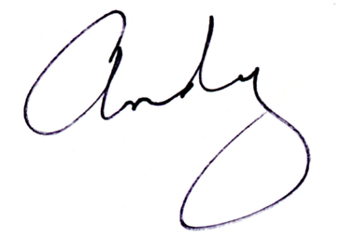
Sincerely,

Andrew M. Loza
Executive Director

