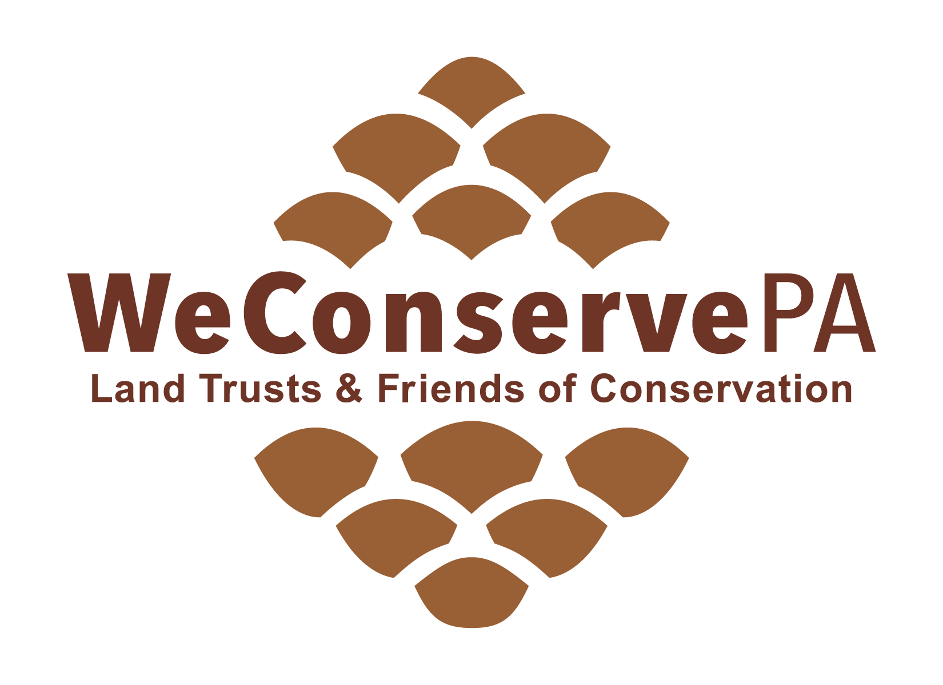
119 Pine Street, 1st floor
Harrisburg, PA 17101

717 230-8560
info@weconservepa.org

Associate Membership Dues Invoice

Please mail this form with check made payable to WeConservePA. Questions? Call us at (717) 230-8560.

Guideline: 1% of your organization’s annual budget for land conservation operations

Organization Name:
 $1500
 $2000
 $2500
 $3000
 $3500
 $4000
 $5000
(maximum)

Select Contribution Level:
 $210 minimum
 $300
 $400
 $500
 $600
 $800
 $1000
 $1200

$ ________ Additional contribution
$ ________ TOTAL

Contact Person:
Street Address:

City: State: Zip:

 In the future, please send this invoice to the following individual, if different than above:
________________________________________

 In the future, please send this invoice to the following mailing address, if different than above:
________________________________________
________________________________________
________________________________________
________________________________________

Please attach a list of your current board members (including: full name, title, mailing and email addresses) with this form.
Board members and active volunteers of member organizations are entitled to receive WeConservePA’s publications and e-mails, including the ConserveLand newsletter at no charge.

Regular voting membership is open to nonprofit organizations who support WeConservePA’s goals and who: acquire land or conservation easements for conservation purposes; or provide stewardship of land or conservation easements; or assist organizations in accomplishing land trust work; or generally advance the cause of land and water conservation.

Government agencies, businesses, individuals, and others may join as Associate (non-voting) Members.
 Check here only if you believe you should be or wish to be classified as an Associate (non-voting) Member.

