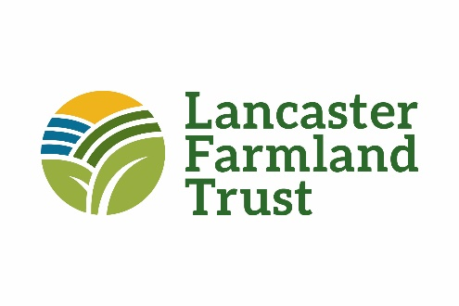
Conservation Program Specialist
Job Description

Essential Duties:

While working closely with LFT’s Vice President of Land Protection, the Conservation Program Specialist is a position within the Land Protection Department responsible for interacting with stakeholders to advance the mission of Lancaster Farmland Trust. This position reports to the Vice President of Land Protection.

The Conservation Program Specialist must be philosophically committed to the mission and vision of Lancaster Farmland Trust and possess a working knowledge of the agricultural industry in Lancaster County and across Pennsylvania. The Specialist is responsible for establishing relationships, and being a liaison, with a variety of stakeholders including farmers, funders, contractors, municipal officials, state and federal officials, and other conservation organizations, which result in advancement of soil and water conservation practices, better environmental stewardship and water quality improvements. Prior experience working with members of the Plain Sect community is required.

The Specialist must understand and be able to communicate the application of agricultural erosion and sedimentation control measures, conservation and manure/nutrient management plans, and is responsible for administering grants and projects associated with these activities. Prior grant and project management experience is highly desirable. While not required, candidates having the certification to develop conservation plans will be given greater consideration for the position.

The Specialist must possess proficient knowledge of Microsoft Office software and working knowledge of ArcGIS and ArcGIS online. This position will require time in the field with varying weather conditions and terrain, and may require travel and occasional overnight stays outside of Lancaster County. A valid Pennsylvania Driver’s License is required.

Specific Duties:

- Grant and Project Management
Conceptualize and develop grant ideas which further the objectives of LFT’s conservation programs. Administer and execute the programmatic outputs of grants and provide support to staff on grant reports. Prepare contracts and bid documents as necessary. Coordinate with famers, contractors, and other third parties to facilitate the successful completion of BMP implementation projects. Coordinate with various partners on BMP documentation, reporting and verification requirements.

- Outreach - Farmers
Establish positive relationships with farmers resulting in greater awareness of regulatory compliance and implementation of conservation practices. Act as a liaison with private and public organizations related to technical service and funding for these activities. Organize and oversee workshops, field days, and other educational opportunities. Develop outreach material to promote LFT’s conservation programs and soil and water conservation.

- Technical Assistance
Provide technical assistance to landowners to implement conservation practices that improve water quality and/or connect landowners to resources available to acquire necessary technical assistance. Work with farmers to develop and implement plans for their farms in accordance with Chapter 91 and 102, and Act 38 regulations.

- Conservation Easement: Acquisition & Stewardship Support
Advance the mission of securing conservation easements via donations and bargain sale payments. Compile complete, accurate and detailed baseline documentation on easement acquisition projects. Maintain databases and records related to current and previous preservation projects. Respond to preserved farm owners and third party questions regarding conservation easements. Facilitate the analysis of reserved right requests and provide direction and approval to landowners to ensure compliance with the easement and accreditation provisions. Meet with subsequent owners of preserved farms to review the conservation easement and baseline documentation report. Assist in conducting the Trust’s stewardship activities including utilizing remote monitoring technology. Schedule and conduct annual conservation easement monitoring visits.
- Organizational Support
Provide assistance to other departments with projects and events as required. Other duties as assigned by the Vice President of Land Protection and/or President and CEO.

Interested candidates should submit a resume, cover letter, and three references to Jeb Musser, Vice President of Land Protection at jmusser@lancasterfarmlandtrust.org

