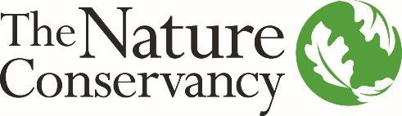
Land Protection Manager – Pennsylvania & Delaware
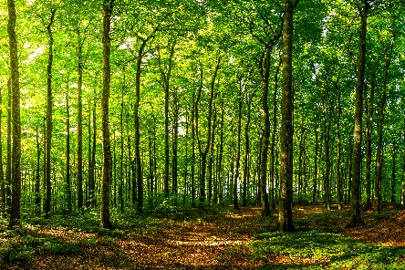
Become a force for nature and a healthy planet by joining our team!

The Nature Conservancy is seeking an experienced project manager with solid communications, partnership building and negotiation skills to be the Land Protection Manager based in Harrisburg, PA. The Land Protection Manager will conduct landowner outreach to develop land protection projects along the Kittatinny Ridge (Appalachians) in Pennsylvania. The Land Protection Manager works as part of a team to protect a critical climate resilient corridor. While the focus of this position will be to acquire fee-title and conservation easements on priority parcels along the Kittatinny Ridge, the Land Protection Manager may work on other land protection priorities across Pennsylvania and Delaware as needed.

In this position, you will be responsible for developing relationships with landowners, negotiating transactions to acquire land and conservation easements, represent TNC in cooperative projects with government and other partners and, where appropriate, transfer land interests to partner agencies. You will develop and implement landscape level land protection plans and work with landowners, Conservancy staff, community members, and federal, state, and local agency professionals to promote protection programs. The Land Protection Manager implements a variety of conservation strategies and employs a full range of protection tools to acquire varying degrees of legal interest in land.

Whether it’s career development, work/life balance, or a rewarding mission, there are many reasons to love life at TNC. The location for this position is in Harrisburg, Pennsylvania and requires time in the field with the flexibility for occasional remote work.

The ideal candidate will have a background and track record that includes:

Minimum Qualifications | Desired Qualifications
- BA/BS, law or business degree and 5 years’ experience in natural resource management or related field, or equivalent combination of education and experience.  - Experience with real estate and land acquisition.  - Experience negotiating complex agreements.  - Basic GIS skills.  - Experience communicating with the public both in writing and verbally.  - Experience using applications such as Microsoft Word, Excel, and Web Browsers. | - 5 or more years of related work experience in conservation, planning, real estate, or other related experience.  - Experience and political savvy in partnership development (community, government, non-profits, business).  - Experience influencing, developing, and implementing conservation policy and plans.  - Knowledge of current trends and strategies in conservation and natural resource preservation and planning.  - Ability to explain conservation to technical and non-technical audiences.  - Strong project and team management skills.  - Excellent communication skills via written, spoken, and graphical means in English and other relevant languages.  - Multi-lingual skills and multi-cultural or cross-cultural experience appreciated.
For more information and to apply, please visit www.nature.org/careers and search for job ID#51090 in the keyword search. Position will be open until 3/24/2022.
The Nature Conservancy is an Equal Opportunity Employer. Our commitment to diversity includes the recognition that our conservation mission is best advanced by the leadership and contributions of diverse people of all genders, backgrounds, beliefs and culture.

Since 1951, The Nature Conservancy has been doing work you can believe in protecting the lands and waters that all life depends on. As a science-based organization, we create innovative, on-the-ground solutions to our world’s toughest challenges so that we can create a world in which people and nature thrive. One of our core values is our commitment to a globally diverse and culturally competent workforce. Visit www.nature.org/aboutus to learn more.
For more information and to apply, please visit www.nature.org/careers and search for job ID#51090 in the keyword search. Position will be open until 3/24/2022.
The Nature Conservancy is an Equal Opportunity Employer. Our commitment to diversity includes the recognition that our conservation mission is best advanced by the leadership and contributions of diverse people of all genders, backgrounds, beliefs and culture.

