Pennsylvania Land Conservation Conference  Mobile Seminar Proposal | 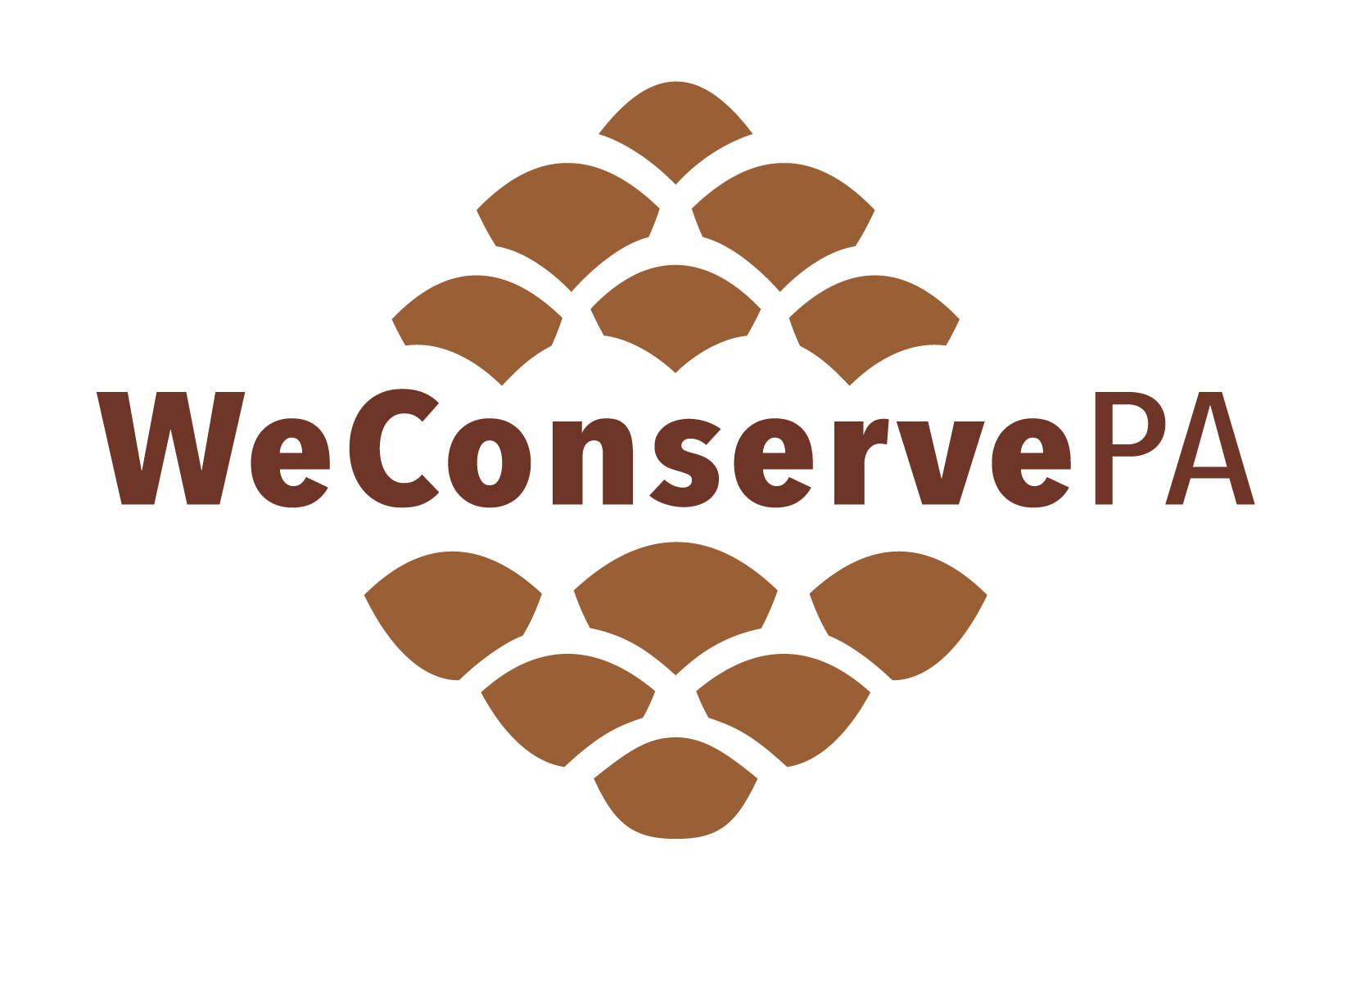

Submission Instructions
- Submit completed proposal to Emily Gates at egates@weconservepa.org no later than December 12, 2025.
- Photographs: Upon submission, please attach 2-3 high resolution images of the mobile seminar location(s) to be used in marketing materials (at least 300dpi and in jpg or png format).
- Final Itinerary: The final agenda and itinerary must be submitted by January 30, 2026. Any changes made after this date must be reviewed and approved by WeConservePA.
- Attendee Information: Any details that need to be communicated to participants in advance (e.g., appropriate clothing, weather considerations, required experience level, or necessary equipment) must be submitted by
March 31, 2026.

Mobile Seminar Organizer
The “Mobile Seminar Organizer” serves as the primary point of contact for trip leaders and speakers, oversees seminar content, and manages logistics such as deadlines and communication with event organizers.

Name
Title
Organization/Affiliation
Phone
Email Address

Trip Leader #1 (required)

You must identify at least one trip leader. This person will be responsible for attending the mobile seminar, assisting the bus driver, handing out materials (if necessary), and keeping track of attendance. Registration discounts will be provided to 1-2 trip leaders per field trip.

Name
Title
Organization/Affiliation
Cell Phone
Work Phone
Email Address
Travel on the bus? (yes/no/not applicable)
Require lunch? (yes/no/not applicable)
Dietary Restrictions? (yes/no/not applicable)
Bio

Trip Leader #2 (optional)
Name
Title
Organization
Cell Phone
Work Phone
Email Address
Travel on the bus? (yes/no/not applicable)
Require lunch? (yes/no/not applicable)
Dietary Restrictions? (yes/no/not applicable)
Bio

Mobile Seminar Title
Please note that WeConservePA reserves the right to change or alter the title, if deemed appropriate.
Please keep to sixty-five characters or less (character counter).

Mobile Seminar Description

Provide the full mobile seminar description, which will appear in marketing materials, including the online agenda. Please include information regarding the accessibility of this trip, including how much walking will be required, type of terrain, surface/slope, and trail surface information, etc. WeConservePA reserves the right to edit field trip descriptions for clarity.

*All input fields will expand as you type, delete “Description Example” before inputting your own.
Description Example:
See how conservation of municipal-owned lands around Lock Haven are being conserved for people and nature. We will start at the Wayne Township Landfill and their mitigation wetlands constructed in the early 1990s and under conservation easement with the Northcentral Pennsylvania Conservancy. Next, we will visit the forest surrounding Lock Haven city's water supply, where the Lock Haven City Authority has a working forest conservation easement with The Nature Conservancy. We will view and discuss forest management successes and challenges while discussing how sustainable forest management operates under a conservation easement.

At least ¼ mile walking total, over gently sloping, uneven terrain. Conditions could be wet and muddy.

EDUCATIONAL TRACKS

Indicate the primary track that best represents this mobile seminar. You may select multiple tracks, however WeConservePA reserves the right to assign this session to the most appropriate track on the final agenda. Options include:

1) Climate Change/Carbon; 2) Conservation Easements; 3) Diversity, Equity, and Inclusion; 4) Education & Outreach; 5) Farmland Preservation; 6) Forestry; 7) Fundraising/Marketing/Communications; 8) Land Protection; 9) Land Use Planning; 10) Organizational Development; 11) Partnerships & Community Engagement; 12) Stewardship/Restoration; 13) Trails; 14) Local Heritage and Recreation Outing or Tour; 15) Other (please indicate).

Date Preference
If you have a preferred date and time from the list below, please indicate it. Preferences cannot be guaranteed.

Wednesday (morning and afternoon), April 29

Wednesday (afternoon only), April 29

Thursday (afternoon), April 30
Friday (morning), May 1
Other

Desired Length of Mobile Seminar
Full-day workshops are scheduled on WEDNESDAY and typically leave at 10AM. Half-day workshops leave at 12PM or 1PM (depending on whether participants will eat with other attendees at hotel or have their meal off-site) and can be scheduled any of the three days. Note: A Local Tour/Recreation Outing is considered an interactive experience that highlights local heritage and/or recreation, fosters networking, and encourages informal learning.

Half Day (3-4 hours) Full Day (5-6 hours) Local Tour/Recreational Outing (1-2 hours)

CAPACITY LIMITS

Indicate the capacity of this mobile seminar (e.g., limited seating at lunch, farm tour that can only handle x number or people at once, etc.).

ITINERARY
Provide your draft mobile seminar itinerary including departure and return times, site visits or stops along the route, and timing for presentations or discussions. This itinerary will ensure trip leaders, speakers, and organizers understand the flow of the day and all logistical details for the mobile seminar.

Keep the following recommendations in mind as you plan:
- Travel Time: Choose destinations ideally within a 30-minute drive of the conference center.
- Route Considerations: Account for potential traffic, construction, or other travel delays when selecting sites.
- Transportation Limits: Confirm with destination hosts whether there are any restrictions on bus size or weight.
- Location Details: Provide both physical addresses and GPS coordinates for each stop on your itinerary.
- Breaks and Facilities: Include time for lunch and restroom breaks, as needed. Buses with onboard restrooms will be reserved if suitable facilities are not available at stops.

Itinerary Example:
10am | Leave Penn Stater [215 Innovation Blvd, State College, PA 16803]
10:45am | Arrive at Wayne Twp's landfill and use restrooms [15 Landfill Lane, McElhattan, PA 17748]
11:00 to noon | Guided tour of mitigation wetlands (NPC has a conservation easement on them) and landfill operation
12:15 to 12:45 | Lunch in the landfill's training room / presentation on the Lock Haven Working Woodlands project.
12:45 to 1:00pm | Travel from the landfill to the forestry stop
- Timber Harvest & Deer Fence: 41.07015, -77.31645 (Log Landing near Ohl Reservoir)
1pm to 2:30pm | Tour stop along Pine - Loganton Road and the Ohl overstory removal / deer fence.
- Timber Harvest: 41.12548, -77.31399 (Log Landing along Pine Loganton Road)
3:00pm to 3:15pm | Stop at Lamar exit for restrooms. [Lamar exit off of I-80]
4PM | Return to the Penn Stater [215 Innovation Blvd, State College, PA 16803]

Mobile Seminar Backup Plan
Mobile seminars are held rain or shine except for extraordinary circumstances. In the event of inclement weather, please describe plans to adapt this tour for the safety and overall enjoyment of participants, i.e. Are there more indoor areas that we could utilize, will specific activities be cancelled? If so, are there alternative activities to which we can pivot?

Speaker #1
A mobile seminar may have multiple speakers. Please include contact information for every speaker. Registration discounts will be provided to all speakers.

Name
Title
Organization/Affiliation
Phone
Email Address
Travel on the bus? (yes/no/not applicable)
Require lunch? (yes/no/not applicable)
Dietary Restrictions? (yes/no/not applicable)
Bio

Speaker #2 (optional)
Name
Title
Organization/Affiliation
Phone
Email Address
Travel on the bus? (yes/no/not applicable)
Require lunch? (yes/no/not applicable)
Dietary Restrictions? (yes/no/not applicable)
Bio

Speaker #3 (optional)
Name
Title
Organization/Affiliation
Phone
Email Address
Travel on the bus? (yes/no/not applicable)
Require lunch? (yes/no/not applicable)
Dietary Restrictions? (yes/no/not applicable)
Bio

Speaker #4 (optional)
Name
Title
Organization/Affiliation
Phone
Email Address
Travel on the bus? (yes/no/not applicable)
Require lunch? (yes/no/not applicable)
Dietary Restrictions? (yes/no/not applicable)
Bio

Speaker #5 (optional)
Name
Title
Organization/Affiliation
Phone
Email Address
Travel on the bus? (yes/no/not applicable)
Require lunch? (yes/no/not applicable)
Dietary Restrictions? (yes/no/not applicable)
Bio

CATERING RECOMMENDATIONS (if applicable)

When offering a full-day tour, lunch will be provided. Please indicate a few restaurants or caterers that you recommend OR indicate if you would prefer a boxed lunch from the hotel.

Business #1 Name
Contact Person (optional)
Website

Business #2 Name
Contact Person (optional)
Website

TRANSPORTATION (if applicable)

Please indicate your transportation requirements and please provide recommendations for transportation vendors. Companies with ADA accessible transport and the availability of onboard restrooms preferred.

Transportation Specifications

Transportation Size (van(s), mini-bus, school bus, other)
Onboard Restroom required (yes/no)

Recommended Transportation Providers

Transportation Company #1
Contact Person (optional)
Website

Transportation Company #2
Contact Person (optional)
Website

Transportation Company #3
Contact Person (optional)
Website

OTHER CONSIDERATIONS

Please indicate any other factors we should know regarding the mobile seminar you are organizing.

