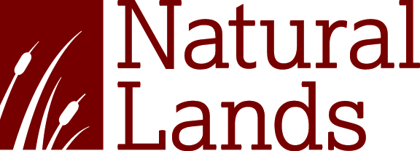

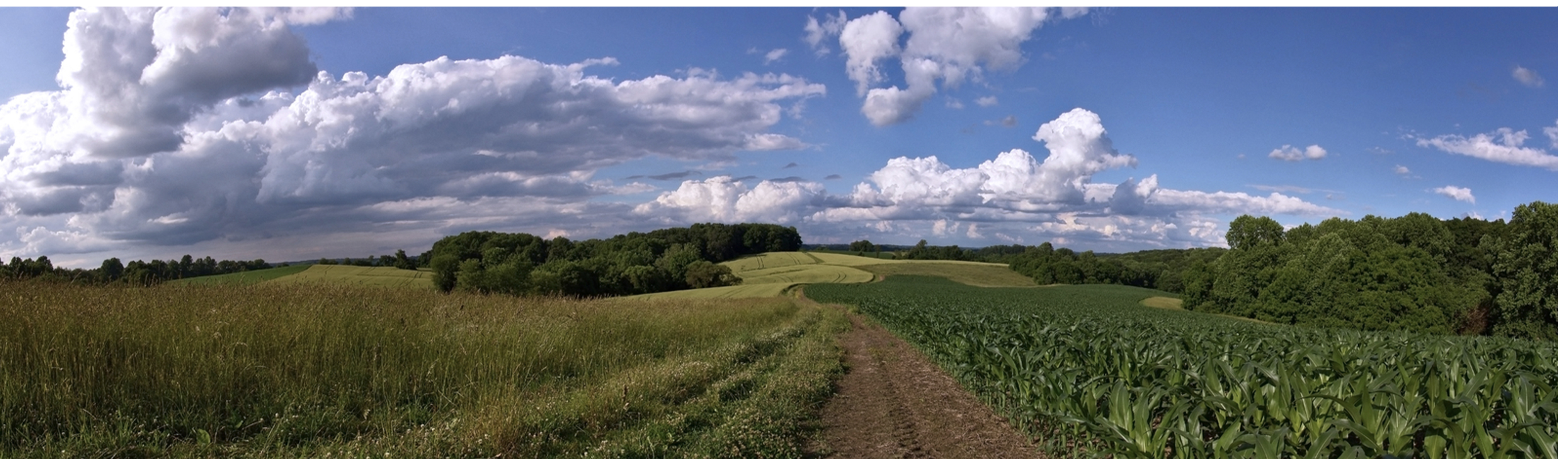

Fellowship Period: One Year Beginning January 2026
Natural Lands is a non-profit organization that saves open space, cares for nature, and connects people to the outdoors in eastern Pennsylvania and southern New Jersey. We’ve been at it since the early 1950s and today more than five million people live within five miles of lands under our permanent protection.

Today, the organization is one of the nation’s largest regional land conservancies and is widely respected for its record of success, technical expertise, respectful and creative approach to partnerships, fiscal strength, and integrity.

Over the course of its nearly 70-year history, Natural Lands has helped preserve more than 135,000 acres including a network of over 40 nature preserves and one public garden across two states and 13 counties. These properties total 23,000 acres and include many of the most spectacular and diverse properties in the region, which are enjoyed by more than 300,000 visitors annually.

Natural Lands has made a commitment to implementing strategies for the improvement of diversity in our leadership and staffing, visitor and member base, and priorities for mission delivery in the fields of environmental land management and natural areas conservation. All applicants interested in bringing their varied lived and learned experiences to the organization are encouraged to apply.

This full-time, 12-month paid fellowship offers the selected applicant the opportunity to gain experience in aspects of land management, land conservation, gain experience in community outreach, and learn the workings of a land trust.

The fellow will work with a designated “field” coordinator(s) and other staff to explore the elements of Natural Lands’ mission with caring for nature, saving open space, and connecting people to the outdoors… and each other. This includes managing the public use and natural resources of the preserve—assisting efforts to restore natural areas; monitoring of conservation easements; and making connections within the industry and the community. Tools used in the course of the work include power string trimmers, brush cutters, hand pruners and saws, chainsaws, lawnmower, truck, and tractor. Training on the use of these tools will be provided.

The fellowship will be augmented by experiences with Natural Lands’ departments – Conservation, Finance, Human Resources, Communications and Engagement, and Development. The fellow will be invited to participate in all-staff meetings and trainings. In addition to the 21st Century Conservation Fellowship, Natural Lands hosts other interns at various preserves and provides opportunities to connect with these colleagues who are also new to the organization.

This is a hands-on position with training provided.

Compensation:

- $16/hour
- Stipend to support living expenses
- This position is eligible for medical, dental, and vision benefits
- 10 days vacation annually, pro-rated based on start date
- 9 scheduled and 2 floating paid holidays per year, pro-rated based on start date
- 5 paid sick days per year

At a minimum, candidates must meet the following requirements:

- Strong and demonstrated affinity for the environment and outdoor activities.
- Commitment to inclusion and belonging efforts.
- Have graduated from an undergraduate or graduate program within a year prior to the start of the fellowship, preferred.
- Ability to work 37.5 hours per week. Generally, this time falls during the traditional workweek; however, some weekend hours will be required.
- A valid driver’s license, reliable vehicle, and a clean driving record.
- Successfully pass a background check.
- Must be able to walk, stand, bend and squat on uneven terrain; must be able to lift and carry up to 40 pounds and push up to 50 pounds.
- Must be prepared to work outdoors under all conditions, including heat, cold, and with occasional exposure to poison ivy, biting and stinging insects, etc.
- First Aid and CPR certification is a plus.

We seek to hire great people from a wide variety of backgrounds, not only because it’s the right thing to do, but because it makes our organization stronger. We aim to build a workplace where employees feel empowered to bring their full, authentic selves to work. Natural Lands is proud to be an equal opportunity employer. All qualified applicants receive consideration for employment without regard to race, color, religion, gender, gender identity or expression, age, national origin, sexual orientation, disability, or veteran status.

