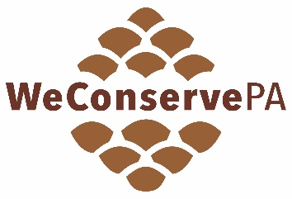
Regional Trail Workshop Grant Application
CHECKLIST

This checklist will help you gather and prepare everything needed for your Regional Trail Workshop Grant application. All items are required to submit your electronic application. Keep in mind that the form cannot be saved midway—it must be completed in a single session. When ready, submit your application here: Regional Trail Grants.

Questions can be directed to Emily Gates at egates@weconservepa.org.

- APPLICATION INFORMATION
  - Organization Name
  - Type of Organization
  - EIN Number
  - Address
  - County
  - Website (entry must begin with https://)
  - Mission Statement

- CHIEF EXECUTIVE INFORMATION
  - Name
  - Title
  - Phone
  - Email

- GRANT CONTACT
  - Name
  - Title
  - Phone
  - Email
  - Address

- REGIONAL TRAIL WORKSHOP INFORMATION
  - Workshop Title
  - Workshop Audience
  - Anticipated Number of Attendees
  - Proposed Date(s)
  - Proposed Location(s)
  - Workshop Description
  - Learning Objectives (minimum of three)
  - Workshop Charges (simple “yes” or “no” if you are charging participants)
  - Workshops Sponsorship and/or Partnerships (if any, be prepared to list them)
  - Workshop Evaluation Method (examples: knowledge or skill assessments, pre/post-workshop surveys, attendee feedback sessions, tests or quizzes, other)
  - Planning Timeline

- BUDGET SUMMARY
- Complete the Proposed Budget Form available here: Regional Trail Grants
The Proposed Budget Form outlines your project’s expected income and expenses and shows how grant funds will be used. It should include itemized expenses, total project costs, the amount requested from the grant, and any additional funding sources or matching funds. Sponsorships and attendee workshop charges are a few examples of additional funding sources.

Completing your Proposed Budget Form will provide the values you need to enter into the electronic application, including:
    - Proposed Total Project Cost
    - Grant Amount Requested (maximum of $5,000)
    - % Grant Amount Requested of Proposed Total Project Cost (not to exceed 80%)
    - Proposed Grant Match (cannot be from other DCNR or WeConservePA grants)
    - % Grant Match of Proposed Total Project Cost (minimum of 20%)

- APPLICATION CERTIFICATION AND STATEMENT OF ASSURANCE
The Statement of Assurance section requires the electronic signature of the organization’s Chief Executive. In electronically signing this section, it confirms applicants’ understanding that they will comply with the rules, regulations, and requirements associated with the Regional Trail Workshop Grant. It serves as a written pledge of responsibility, accountability, and legal compliance.
  - Authorized Certifier’s Name (organization’s Chief Executive)
  - Title
  - Date

