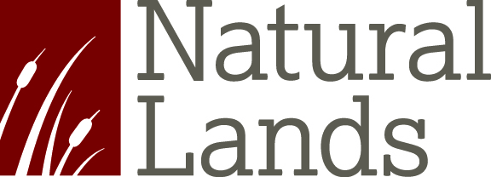
Stewardship Assistant - North
Natural Lands is a non-profit organization that saves open space, cares for nature, and connects people to the outdoors in eastern Pennsylvania and southern New Jersey. We’ve been at it since the early 1950s and, today, more than 2.5 million people live within five miles of lands under our permanent protection.
The Stewardship Assistant is responsible for assisting Preserve Managers and Building Stewardship staff. Duties will include land management and maintenance of equipment, roads, and structures. This will include operation of power equipment, such as chainsaws, tractors, and lawn mowers. The Stewardship Assistant will be required to physically perform, as needed, any and all tasks necessary for the maintenance of any Natural Lands’ Preserve and to occasionally work weekends, evenings, and holidays as requested to fulfill his or her responsibilities. The position will primarily assist Preserve Managers in Northampton, Bucks and Montgomery counties, although you may serve from time to time at all of the Natural Lands’ locations.

The successful candidate will have:

- Highly motivated, responsible, reliable and dependable.
- Capable of performing a wide variety of physically demanding tasks
- Must have a valid driver’s license, reliable transportation and a good driving record
- Customer service attitude and be comfortable working with the general public.
- Flexibility when dealing with changes in work plans
- Carry out tasks in a professional manner.
- Adequate skills and a familiarity of the safe operation and care of basic hand and power tools.

We seek to hire great people from a wide variety of backgrounds, not only because it’s the right thing to do, but because it makes our organization stronger. We aim to build a workplace where employees feel empowered to be their full, authentic selves. We welcome you to explore a career at Natural Lands.

Natural Lands is committed to creating a diverse environment and is proud to be an equal opportunity employer. All qualified applicants receive consideration for employment without regard to race, color, religion, gender, gender identity or expression, age, national origin, sexual orientation, disability, or veteran status. We aim to build a workplace where employees feel empowered to bring their full, authentic selves to work. We welcome you to explore a career at Natural Lands.

TO See a Full Job Description or to APPLY: visit our website at www.natlands.org/everything-else/job-opportunities/
and complete the online application process. Please address all applications to Jeni Albany, Director of Human Resources.

